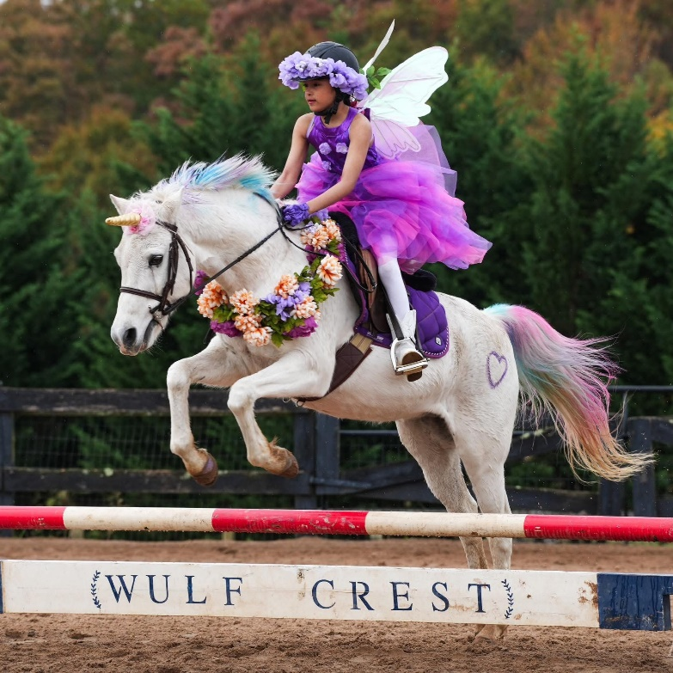
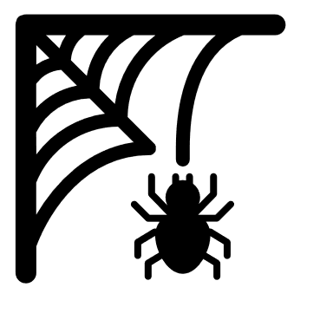
Halloween Jumper Schooling Show

October 25, 2025
9am Start Time


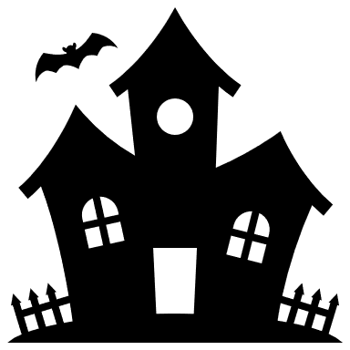
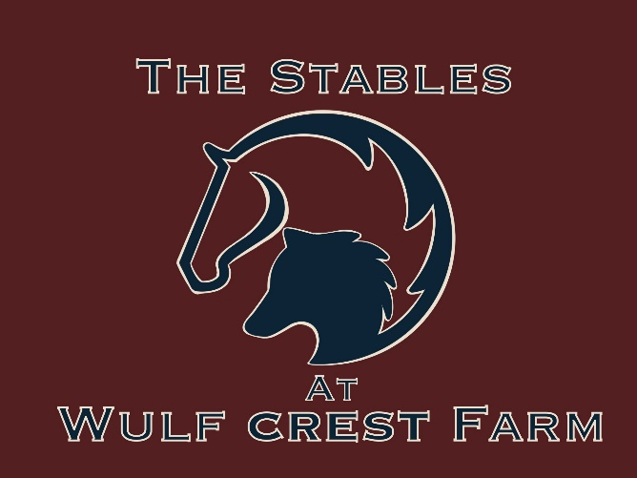

Food and Halloween candy will be on site!
Trunk or Treating!
19876 Rider’s Success Ln, Leesburg, VA 20175
Dress in your best costume! A Costume class will run between 2’ and 2’3”!
Schooling Jumper show. 1st trip clear round blue ribbon (Halloween themed!), 2nd trip will be timed 1st-6th with ribbons and prizes! $20 a round!
Ride as many times as you want! To register please go to strider.com. Please email shows@wcfstables.com for any questions or enquiries. We look forward to hosting you and your horse at our beautiful facility!
Heights will start with ground poles up to 3’6”. We are more than happy to go higher that what we are advertising, just ask our in gate!

The Stables at Wulf Crest Farm

