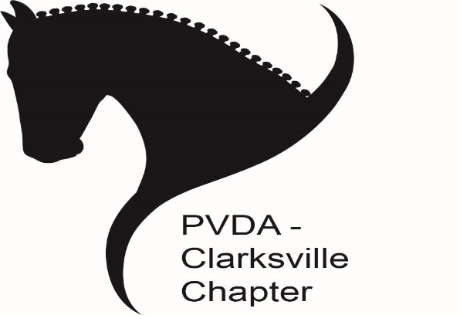
PVDA Clarksville Chapter Winter Series Show #1
Holiday and Benefit Show in Honor of Nikki Witte
Sunday December 15, 2024
Stonebrook Farm, 6300 Guilford Road, Clarksville, MD 21029 Judge: Jenna Brown (L)

Show Managers:  Pam Deem-Hergan  (443) 386-1536  Tracey Trainum  (410) 733-2501  Email Contact:  Clarksville.pvda1@gmail.com | Open:  11/9/2024  Registration:  Striderpro.com  **Online entries  only** | Close:  12/5/2024  @9:00 pm
Classes: $30  PVDA non-member fee: $10  Additional fees if payment is through striderpro.com | Show will close early if oversubscribed | Theme: “Ugly Holiday Sweater”
Show information: Holiday and benefit show in memory of Nikki Witte. $5 from each entry will be donated to the American Lung Association in Nikki’s memory. The Chapter will match the money raised from entries for donation. Costumes encouraged but not required. Fun, family friendly environment. Holiday open house with food and drinks.
Classes: All USEF/USDF levels including lead line through FEI, Event tests, and Western dressage. 2023 Dressage tests in effect for this show.
Payment: Must be received by closing date or entry is forfeited.
Option 1: During checkout on striderpro.com via striderpay. Additional fees apply.
Option 2: Direct PayPal to Clarksville.pvda1@gmail.com . Please use this email address when using PayPal to avoid paying main PVDA.
Options 3: Check payable to “PVDA Clarksville” received by closing date. Dropped off at Stonebrook Farm (address above) & left on desk inside indoor arena. Or mail to: Tracey Trainum. 904 Magnolia Blossom Court. Sykesville, MD 21784
*PLEASE NOTE PAYMENT CHOICE IN COMMENTS IN STRIDER ENTRY *

Classes/Ribbons: Tests are ridden out of order due to scheduling/trailer accommodations. To facilitate show efficiency, day of show ribbons will be pinned based on individual percentage results rather than class place. At the end of show, results by level/test will be posted but no additional ribbons will be awarded. All scores recorded towards series level awards.

Series End Awards: Awards will be given at each level with three or more qualifying riders. Eligible levels include Introductory, Training Level, First Level, Second & Above, MFS, Western dressage, and Event tests. To be eligible, a rider must attend minimum of two shows and complete three rides at the same level with the same horse/rider combination. Musical freestyle competitors are required to attend two shows and complete two rides. For rider/horse combinations with more than two rides, the lowest score will be dropped, and all other scores averaged. For rider/horse combinations with two rides, both scores will count. A minimum average of 55% is required.
Registration: Reserve a spot via http://www.striderpro.com. Only completed online entries via StriderPro will be accepted. A completed entry includes the online StriderPro entry form, current coggins, proof of PVDA membership (or non-member fee), & payment. Entries are accepted in order in which they are received. Striderpro registration does not guarantee entry.
Trailer parking: There is limited parking and backing up will likely be required. If you are trailering with more than one horse, please specify the size of your rig, the number of entrants and their names.
Payment: Payment must be received by closing date or entry is forfeited. PVDA VOLUNTEER CERTIFICATES ARE NOT accepted at Chapter events for payment.
Times: Will be posted on the Chapter Facebook page and emailed to participants no later than Thursday before the show.
Additional Information: Small outdoor arena for warm-up - weather permitting. Regulation size indoor arena with sound system for musical freestyles. Classes will be run out of order and may not be pinned until the end of the day. NO REFUNDS for scratches made after the closing date. Refunds will be issued in the event of show cancellation. However, the office fee and Striderpro.com service charges/credit card processing fees & ARE NOT refundable under any circumstances (ex. scratches made before closing date, entry moved to wait list, or the show is cancelled). Rides are not transferrable.

Scholarship Raffle: After the completion of the winter series the Clarksville Chapter will award two $100 scholarships toward any horse related activity. Each ride receives one raffle ticket and four hours of volunteer service receives one raffle ticket. One scholarship will be drawn from riding tickets and one from volunteer tickets. Clarksville Chapter officers are not eligible to participate.

